Snake River Continuous Improvement Plan
2018-2019

(Revised September 2018)

School District | # 52 | Name: Snake River School District
Superintendent | Name: David L. Kerns |  | Phone: (208) 684-3001
 | E-mail: kernndavi@snakeriver.org
Plan Contact | Name: Sherrilynn Bair |  | Phone: (208) 684-3001
 | E-mail: bairsher@snakeriver.org

Mission and Vision

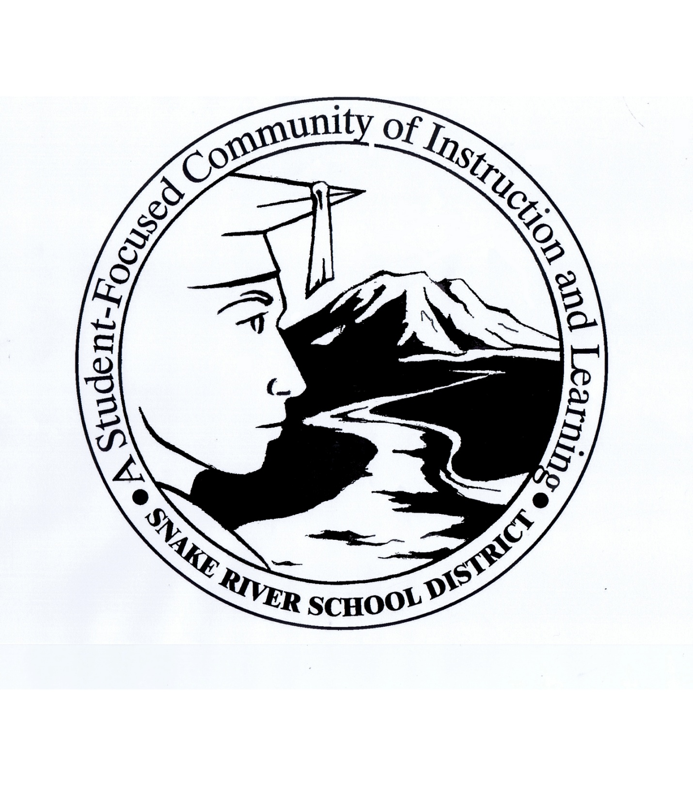

Mission:
Learning Together Every Day.

Vision:
Snake River School District is a collaborative learning community that cultivates an empowering 21st century education.

District Description:
Snake River School District #52 is a rural school district located near Blackfoot, Bingham County, Idaho. Blackfoot is a growing community nestled in the heart of Bingham County. It is the county seat with a population of 37,000 in a 15-mile radius. Other communities in Bingham County include: Shelley, Firth, Aberdeen, Moreland, Riverside, Thomas, Rockford, Pingree, and Atomic City. Bingham County has five school districts, Idaho State University is just a 25-minute drive south of Blackfoot, the College of Eastern Idaho and extensions of the University of Idaho and BYU-Idaho are within a 35-minute drive north in Idaho Falls. The Snake River School District resides in a community considered the largest producer of Idaho Russet potatoes in the world. The community is also home to many agricultural businesses that produce grain, sugar beets, and livestock. In addition, the district is located 40 miles east of the U.S. Department of Energy site and the Idaho National Laboratory. Other entities such as a local hospital, restaurants, retail and grocery stores make up the local economy.
Snake River School District #52 has an enrollment of 1782 students and employs approximately 220 staff members. The District, along with other districts in Bingham County, has a transient population of students. In the 2018-2019 school year, the district experienced an increase in student enrollment of 16 students. The demographics of student population include the following:
- Approximately 80% of the students are identified as Caucasian.
- Hispanic student enrollment is close to 16%,
- Over 40% of the student body is classified as low socio-economic.
- Snake River School District has 3 elementary schools, 1 middle (intermediate) school, 1 junior high school, and 1 high school.
- The District currently operates on a 4-day week, with 142 regular school days a year.
The Snake River School District will measure its academic achievement by state mandated Idaho Standards Achievement Test (ISAT), Scholastic Aptitude Test (SAT), and other formative and summative assessment testing; college and career opportunities for students; and enrollment growth or decline of the school district.

As education evolves, the Snake River School District will work with qualified educational partners and supporters to be a leader in rural education innovation and delivery. We seek to have a profound and caring impact on our students and to be regarded as an exemplary learning community.
The Idaho State Board of Education has directed that each school district develop a Continuous Improvement Plan to be reviewed each year. The Snake River School District contracted with Dr. Heather Williams as the facilitator of the planning process.
Values:
As patrons, parents, employees, and students of Snake River School District #52, we believe in basic values that build and empower our students to cultivate real world skills and provide a quality educational system replete with a variety of experiences and opportunities for success in the 21st century. We are committed to maintaining a caring, community-based school district that engenders mutual respect and strives to develop support from patrons, nearby colleges and universities, and local businesses. We seek innovative and adaptive strategies and embracing change to better serve our students as well as those responsible for enhancing their learning opportunities. Our teachers and administrators seek to utilize engaging instructional strategies and technology to create student-centered lessons that lead to meaningful real world applications. Snake River School District will continue to implement best practices to focus on student learning, effective teacher and staff collaboration, and improved results in preparing students for college and career readiness.
Goals:
- As patrons, parents, and employees of the District, we will improve student engagement by establishing a focus on learning in every class and activity through effective instruction and also increasing advanced courses for gaining college credit as well as certification opportunities prior to graduation.
- We will continue to innovate and seek best practices through collaboration and partnering with other educational institutions and also with the private sector, such as apprenticeships, etc. The District will strive to be student-centered to maximize learning and collaboration among all District stakeholders.
- We will communicate with one another to share ideas, express thoughts and feelings, and resolve problems. There will be a continued focus on results and use data to assist in driving instruction. We will utilize digital media to communicate with the public and strive to promote the positive accomplishments of our students and staff members.

Demographic Analysis

 | 2017-2018 | 2018-2019
Male | 936 | 931
Female | 830 | 855
White | 1412 | 1432
Black/African American | 12 | 12
Asian | 14 | 14
Native American | 45 | 44
Hispanic/Latino | 283 | 280
Free/Reduced Lunch Program | 645 | 649
Received Special Education (IEP Students) | 182 | 184

Community Involvement
Committee Members:
Dave Kerns – District Superintendent
Sherrilynn Bair – District Curriculum Director
Rose Larson – District Special Education Director
Bryce Salmon – Snake River Junior High Principal and Parent
Jennifer Capell – Riverside 3rd grade Teacher and Parent
Vicki Howell – Riverside 3rd grade Teacher and Parent
Lisa Warren – Moreland Kindergarten Teacher and Parent
Marci VanOrden – Trustee, Zone 5 and Parent
Breanna Horan – Parent
Julie VanOrden – District Patron, Idaho State Representative, District 31, Seat B, Chair, House Education Committee, Member, Agricultural Affairs Committee
Kassidee Campbell – Snake River High School Student
Tate Gilbert - Snake River High School Student
Hannah Higginson - Snake River High School Student
Kenya Leavitt - Snake River High School Student
Dr. Heather Williams – Consultant and Facilitator

- The committee members listed above met together and in collaboration with District administrators and students, parents and community members were consulted regarding all three elements of the Continuous Improvement Plan, including the College and Career Advising Plan and the Literacy Intervention Plan. Efforts were made to bring parents in to discuss the College and Career Advising and Literacy Intervention portions of the Combined Plan on other occasions to help further discussion toward meeting District goals and also to comply with Board Policy #6510, Parental Rights and Involvement.

- Parents are notified of the College and Career Advising resources via letters home beginning in the 8th grade to discuss the students’ four-year plan and the advanced opportunities available throughout their 8th grade and High School years. Digital media is also employed, such as Facebook and Twitter notifications and via the District’s SchoolWay app that is compatible with cell phones and internet-capable tablets. Parent nights are held for freshmen and sophomores to continue discussion of advanced opportunities and test results of ISAT and PSAT scores. Members of the junior class and their parents/guardians are invited to meet individually with the College and Career counselor after school hours during the regular school year. Scholarships are broadcast out to the school’s patrons through the Snake River School District FaceBook page and SchoolWay app. Two separate FAFSA Nights are coordinated with ISU/TRIO representatives to help seniors and their parents negotiate the FAFSA experience in the months of October and January.

- Parents are informed of their child’s literacy progress at regular parent teacher conferences. Parents of students who score a 2 or a 3 on the IRI are notified that their child will be receiving additional literacy instruction during K+, Core+ More and/or Friday School. A letter is sent home to notify parents about the additional instruction. Parent input is considered in developing an intervention plan by acquiring information about their families’ interests, schedules, education and literacy backgrounds, and goals for their child.

LITERACY INTERVENTION PROGRAM
Literacy Program Summary

A separate committee consisting of two building administrators, Janae Petersen and Jane Reynolds, principals of Riverside and Moreland Elementary schools, respectively, the District Curriculum Director, Sherrilynn Bair, and three parents, Sydney Anderson, Monica Barnes, and Erin Dance, developed the Snake River School District’s Literacy Plan. All three parents have children in the critical elementary grades – Kindergarten through 3rd. Moreland Elementary houses our Pre-School, Kindergarten, and 1st grades, and Riverside Elementary houses our 2nd and 3rd grade students.

The Idaho Comprehensive Literacy Plan, approved by the Idaho State Board of Education December 2015, has one goal: literacy growth for all students. Snake River School District has adopted the International Literacy Association (ILA) definition of literacy:

Literacy is the ability to identify, understand, interpret, create,
compute, and communicate using visual, audible, and digital
materials across disciplines in any context.

The ability to read, write, and communicate connects people
to one another and empowers them to achieve things they
never thought possible. Communication and connection are
the basis of who we are and how we live together and interact
with the world.

The above definition guides this plan and therefore our work.
Snake River School District #52 has implemented the following initiatives under the direction of the Idaho State Department of Education:
- Idaho Reading Indicator (IRI by IStation) assessment for all students grades K-3 at least twice a year, to identify students performing below grade level.
- Extended Reading Intervention (ERI) time to provide additional instruction beyond the regular school day to K-3 students below grade level (2’s and 3’s).
- All teachers must pass the Idaho Comprehensive Literacy Course/Assessment to strengthen teacher knowledge of foundational literacy skills.

Snake River School District has defined the following objectives to meet the literacy needs of students:
- K-3 students will be screened 3 times a year using a nationally normed, research-based screening tool. (STAR Early Literacy and STAR Reading Assessment)
- K-3 students will receive targeted interventions based on specific skills students are ready to learn, identified by STAR Assessments, Imagine Learning and teacher-created assessments.
- K-3 students scoring a 2 or 3 on the Fall IRI will receive an additional 72 hours of literacy instruction.
- Multiple data points will be used to determine literacy skills (Imagine Learning, STAR Assessments, IRI, Aimsweb, Really Great Reading, and Grade Level Common Assessments)
- Regular data meetings will be held to discuss progress monitoring, interventions, and progress toward goals. Instruction will be adjusted according to data trend lines.
- Riverside Elementary piloted the IStation IRI in 2017-18 and will be using their baseline data to move forward.
Snake River School District’s Literacy Plan includes:
- Use of research based instructional products and strategies to improve literacy.
- Use of multiple measures to monitor and improve literacy skills.
- Increased efforts to include families in literacy activities and instruction.
- Professional Development.
- Professional Learning Communities.
Focus areas include but are not limited to:
- Phonemic Awareness
  - Awareness of sounds including recognizing and manipulating individual sounds.
- Phonological Awareness
  - Rhyming, deleting sounds, segmenting sounds, comparing sounds and isolating beginning, middle, and ending sounds.
- Decoding/Phonics
  - Blending words in sentences, whole word blending, vowel first blending, phonograms, and sound by sound blending.
- Fluency
  - Guided oral repeated readings, Cloze Reading, paired reading, teacher led choral reading, partner reading and novel reading.
- Comprehension
  - Main idea, cause and effect, author’s purpose, and retelling.
- Vocabulary
  - Context clues, direct instruction, personal connections

Snake River students will receive the required hours of literacy instruction by participating in Core+More time, K+, and Friday School (beginning January 2019-May of 2019).
Snake River School District will use the following intervention tools during the 2018-2019 school year.
Interventions to be used at each grade level
- Imagine Learning (Grades K-2)
- STAR Instructional Reports (Grades K-3)
- Really Great Reading (Grades K-3)
- Aimsweb
- Istation
In addition to the above intervention tools, teachers use a variety of research-based strategies for intervention purposes such as: before, during, and after reading strategies, comparing and contrasting and close reading. Close attention is paid to the foundational skills identified above.
The district will support Moreland and Riverside Schools in implementation of this plan by providing funds and professional development.
Literacy funds have been budgeted as indicated on Template 2. Literacy funds are used for the following purposes: (see Template 2 for details)
  - Curriculum Facilitator
  - Salaries and benefits for Friday School teachers and paraprofessionals
  - Imagine Learning Software
  - Renaissance Learning
  - Really Great Reading
  - Friday School Supplies

Snake River has five (5) full professional development days during the school year. Teachers are also encouraged to include literacy instruction as part of their Individual Professional Learning Plans. District professional development days include building, district, and regular collaboration with other districts. Snake River and Blackfoot School Districts collaborate on multiple professional development topics, including MTSS, data analysis, and WIDA instruction.

Comprehensive Literacy Plan Alignment

Snake River School District’s Literacy Intervention Program includes these Essential Elements: Collaborative Leadership, Professional Development for all teachers, Effective Instruction and Interventions and attention to Assessment and Data.
Collaborative Leadership
Collaborative Leadership is key to any successful educational program. Snake River School District follows the Professional Learning Communities (PLC) model promoted by Dr. Rick DuFour, Dr. Bob Eaker and Rebecca DuFour. We recognize these basic principles of collaborative leadership. 1) Expectations of high levels of learning for all students, 2) Collective responsibility and focus on learning above teaching, 3) seeking and using evidence of student learning to guide instructional practice.
Developing Professional Educators
Snake River School District is committed to developing professional educators. Five (5) professional development days are funded by the district, in addition to Leadership Premium dollars for leadership teams working outside of contract days.
Effective Instruction and Interventions
Snake River is committed to improving learning for all students and teachers by monitoring data to ensure that Tier 1 (classroom instruction), Tier 2, and Tier 3 interventions are helping students improve targeted skills. Using Mileposts to track student progress allows teachers to be responsive and adjust instruction and interventions as needed.
Assessment and Data
Snake River staff members are committed to using data to monitor proficiency, growth, and growth toward proficiency. STAR, Mileposts, Imagine Learning, and IRI all provide data that help guide instructional decisions. Grades K-3 have weekly data team meetings.

COLLEGE AND CAREER ADVISING AND MENTORING PROGRAM
College and Career Advising Model

 | Model Name | Additional Details
 | School Counselor | X
 | Teacher or paraprofessional as advisor
 | Near Peer Mentoring / Mentoring
 | Virtual or Remote Coaching
 | GEAR UP
 | Transition Coordinator
 | Student Ambassadors
 | HYBRID (please list all models used in Details)

Advising Program Summary

Summary of college and career advising and mentoring used at each grade level (available resources/services by grade level or group of grades):
Grade 8 – Junior High students are set up with an account in (CIS) Career Information System and a 4-year plan is created before entering High School. A parent night is created to explain Advanced Opportunities programs to parents and students.

Grade 9 – Freshmen students are enrolled in our Introduction to Careers & Study Skills course and are then further involved in CIS by the counselors during class time. Occupation exploration activities are of primary interest.

Grade 10 – Sophomore students, after taking the PSAT/NMSQT test, are given an interpretation of their results during class time. Students are shown how to use the PSAT as a tool in conjunction with Khan Academy, in preparation for a possible additional PSAT test in the fall before the upcoming SAT test in the spring of their junior year. This information will also be shared with parents and students again in the form of a Sophomore Parent Night after PSAT results are made available in December.

Grade 11 - Junior students and their parent(s) or guardian(s) are scheduled to meet individually with the CCR after school hours to research the following college and career resources: Apprenticeships, Holland Code Interest Inventories, Exploration of Careers of Interest, ACT/SAT Preparation Opportunities and Programs, Resume Building Trainings, College/University Programs of Study, and finally, Scholarship Search and Acquisition Mentoring. The Nextsteps.idaho.gov site, the cte.idaho.gov site and other helpful resources are also introduced to the students and parents during these appointments.

Grade 12 – Senior students are newly being required to take our Senior Project/Transition course, where they will be writing a research paper on their senior project as well as preparing themselves for postsecondary situations. Students update and create resumes, ask for and collect letters of recommendation, apply for FAFSA (2 FAFSA nights), practice writing college applications and scholarship essays, apply for college/universities (through the Idaho College Application Week), apply for scholarships, and learn strategies for how to have a successful college freshman experience.

Summary of 2018-2019 School Year College & Career Advising Efforts:

The College and Career Advisor (CCA) for our district, the high school counselors, and registrar have all attended the Advanced Opportunities Workshop at the ISU campus on May 3, 2018.

The CCA attended the CTE Conference in Boise on July 30, 31, August 1 and 2, 2018.

The CCA and his fellow high school counselor attended the IACRAO workshop at BYU-Idaho in Rexburg on September 17, 2018. There will be an event in March of 2019 featuring higher education days for high school juniors.

The CCA has collaborated with 12th grade English teachers to create a “Senor Project Class”. This class incorporates assignments that will help students with the writing of essays for college applications and scholarship acquisition, writing of resumes, acquiring “Letters of Recommendation” and preparing students for life after high school.

Scholarships are being broadcast out to the school’s patrons through the Snake River School District FaceBook page and SchoolWay app.

We are utilizing MyCollegeOption surveys for our 9th thru 11th graders optimizing feedback for our student’s college and career goals.

The CCA and high school counselors will attend a College Board workshop in Pocatello on August 11, 2018 (The plan is to use PSAT reports in an effort to identify and re-teach PSAT test components, which are commonly low).

Two separate FAFSA Nights have been coordinated with ISU/TRIO representatives to help seniors and their parents negotiate the FAFSA experience in the month of October. There will be a follow-up meeting for parents and students in February.

The Idaho College Application Week (ICAW) is scheduled for October 23 and the 24, 2018, where counselors, staff, and college representatives will help seniors apply to at least one college or university. There will be another follow-up on November 1 with a specialist, Joy Miller.

The CCA works throughout the year with our 9th grade Intro to Careers/Study Skills classes and assisting staff and students through CIS assessments and occupation exploration.

The CCA has invited every junior (137) and their parent(s) or guardian(s) to make an appointment after school hours to discuss college/career options, resources, and avenues. This is progressing well and will continue throughout the year.

Snake River High School will co-host a College Fair for Bingham County schools, which has been tentatively set for December 11, 2018. Many colleges and universities will participate and give students an accurate view of their offerings and programs as well as scholarship opportunities. Community businesses will also be present to speak to our students about job opportunities and apprenticeships.

An ASVAB test will be administered to the junior class on January 15, 2019, and an interpretation thereof will be available later in the year. The interpretation is accompanied by a very good Holland Code Interest Inventory activity to help students realize career area strengths.

In the second Trimester, two ACT/SAT Prep classes have been added to the registration guide to help students prepare for ACT/SAT testing.

The College of Eastern Idaho now offers a scholarship workshop. This new opportunity is very informative and helpful to our College and Career Advising program.

